MARKS OBTAINED

_________________
TOTAL MARKS : 50
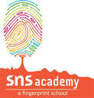
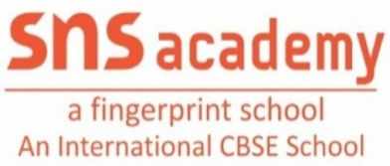
ASSESSMENT -1
NAME: _______________
CLASS: UKG _______
DATE: _____________
SUBJECT: ENGLISH
I. Write the first letter of the given picture: (4x1=4)

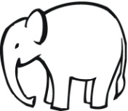
a. b.

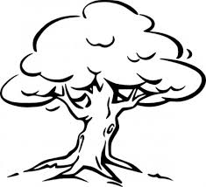
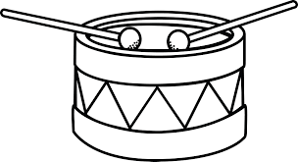
d.
c.

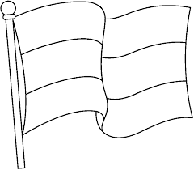
II. Fill in the blanks using the given clue: (ab,ag,am) (2x2=4)
a. b.

Fl __ __ l __ __

III. Put tick ( ) on the pictures that show Near: (2x1=2)
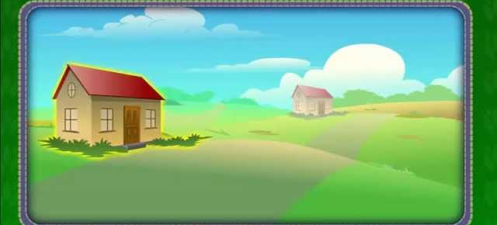
1. 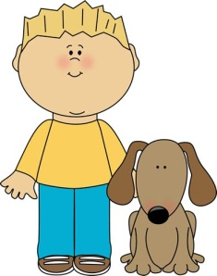 2.

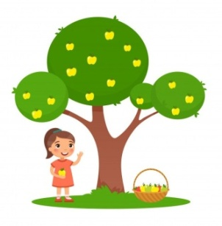

3.

IV. Circle the picture that show far: (2x1=2)
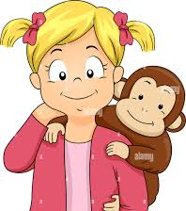

V. Look at the picture and name them : (am,ag,ab) (3x2=6)
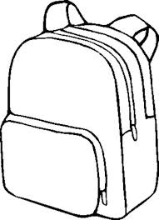

___________ _____________ ___________
VI. Fill in the blanks with “l” or “r” blends: (3x2=6)
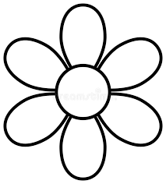

F____OWER B__USH C___OCK
B__USH

C___OCK
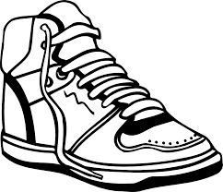
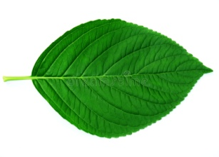
VII. Circle the picture that has “sh” sound : (2x1=2)
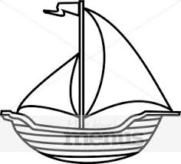
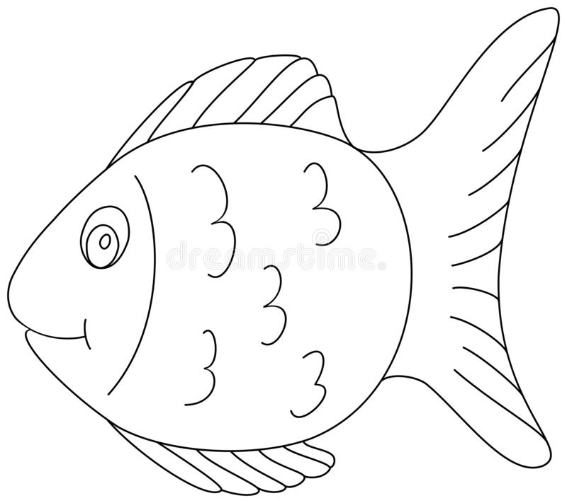
VIII. Write the missing letters : (2x2=4)
1. B ______ D ______ F
2. k ______ m ______ o
IX. ORAL : (20)

********** ALL THE BEST **********

